Name
Tutor
Institution
Date
Woodbury University student Housing
Details
The standard container makes room for eight feet space of width, eight feet six inches space of height and twenty feet in length. There also comes a dimension forty feet of length and eight feet wide and eight feet high. There is a third option which though is harder to find, offers better heights of ceilings. The containers measures forty feet long and nine feet six inches tall rather than eight feet six inches high. While the container can offer a plan of 150 square feet. Though it is really small space, the integration of many containers can give a bigger and better, more beautiful but more affordable space.
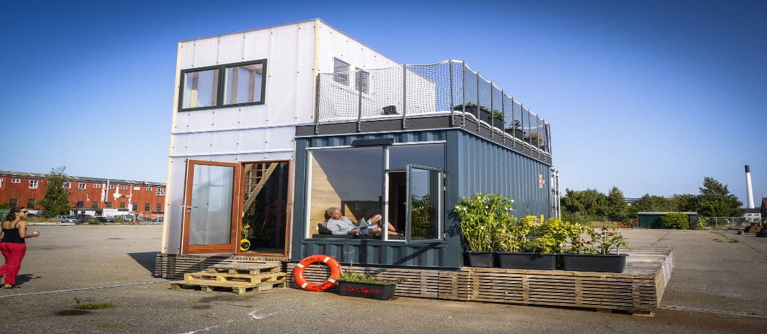
The houses will be designed in a way that would maximize the space that these container buildings will provide. Material and colors used in the construction and design will be adaptable to the natural environment of the Woodbury University, north parking lot. As earlier noted, the container housing design solution will provide a minimum of one hundred and fifty square feet of space for occupation by the students in boarding. Space, however, can be adjusted according to the desires of the administration of the Woodbury University. Each unit shall accommodate one occupant here the following measurements shall be employed in the interior designs of the housing units for Woodbury University, North parking lot;
- The living room which doubles as the bedroom and the working room will be a maximum of 80 square feet and a minimum of seventy-five square feet.
- The Bathroom, which will include the shower, the toilet, and the lavatory will occupy at thirty square feet.
- The Kitchen area, which will include the sink, the stove, and the refrigerator will measure maximum of fifty square feet and a minimum of forty-five square feet.
- The measurement of the container housing solution will not exceed a space of two hundred square feet, and the height of the houses shall not exceed twelve feet high.
- Air conditioning will be independent in each unit, and larger openings such as windows will be installed to ensure maximum lighting of the housing units.
- Electric heating will be installed independently in each housing unit in the Woodbury University North Parking lot. However, despite the independent setting of the air conditioning and heating of the housing units, each pod will be identical to each other and compatible for purposes of clustering them together to make one larger unit of the same.
Schematic design;
The contractor proposed the schematic design below;
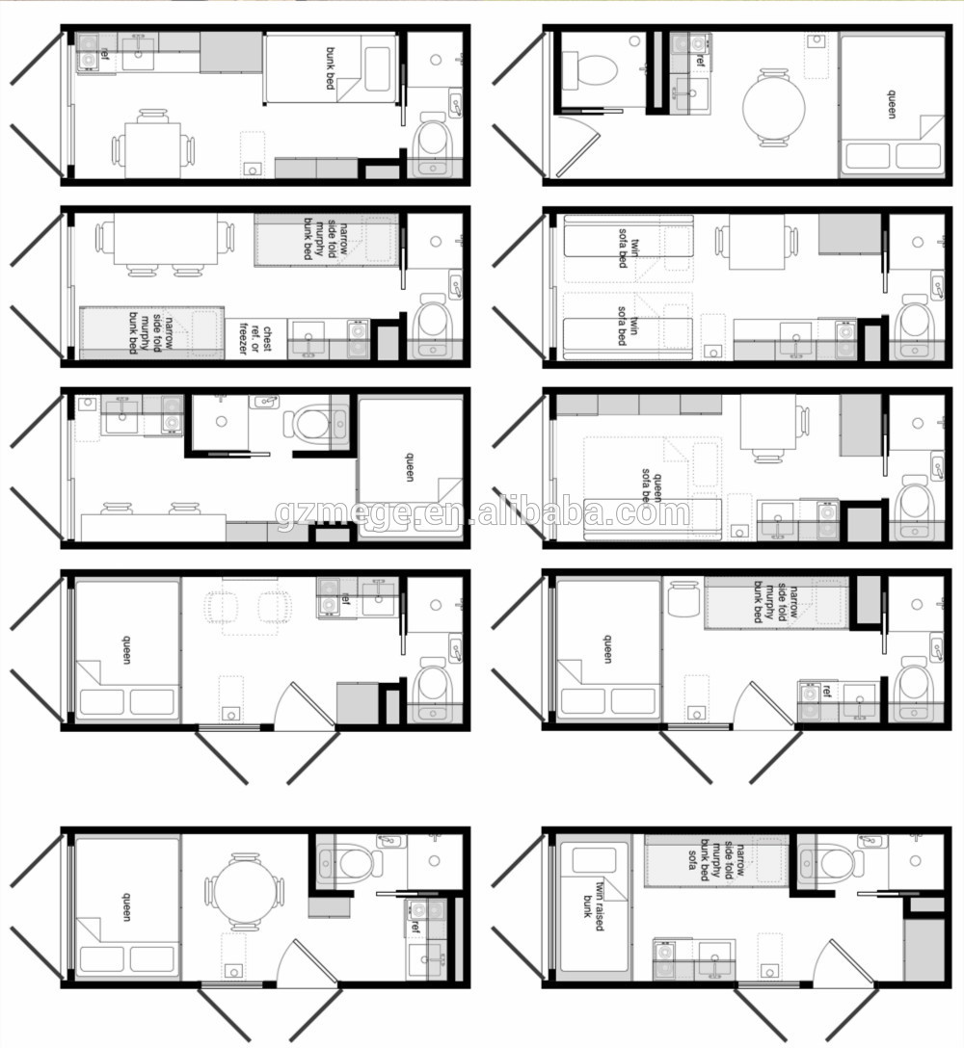
Design development
The housing project will be done in our phases each entailing completion of the ten units before heading on the next phase.
Sample students Housing units
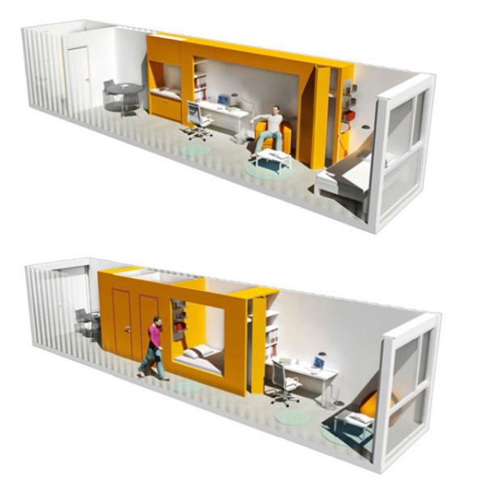

Sample Completed phase
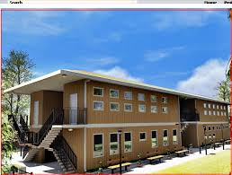
Purchasing services
The purchasing services will be assigned to the SRP purchasing services department for efficient purchasing and supply management t during the period of the project.
, Materials
Materials that will be used for internal designs will include; industrial wood, plywood, glass paneling, industry motifs, blending such as natural light, foldaway glass doors, vegetation including flowers and trees.
Reimbursable expenses;
An expense that is to be reimbursed shall be limited only the expenses that the contractor will incur in service that are directly attributed t the project. Any expenditure that the contractor will directly incur in service to the project must be forts approved by the university administration for the purpose records prior expenditure. Rerecords for all expenses that are pertinent to compensation will be maintained in a filed record and receipts included with the invoice for all expenditure above $100.
Terms of compensation
- Compensation shall be done in half upon initiation of the container housing solution project for Woodbury University. It shall be completed in full upon the completion of the project.
- Compensation shall only be done when and if;
- The client is satisfied with the quality of the work done
- The entrance has completed all the term of the projected.
There can only exist exceptions when due to unavoidable circumstances, the project cut short but the time of project had lapsed. The project due to unavoidable circumstances cannot be completed, but the project was done up to ¾ of the activities in the schedule.
General conditions;
Extra charges
Extra services incurred in the service for that project shall only be undertaken upon approval by the owner, Woodbury University administration. These shall be effected in the total compassion upon completion of the project.
Disclaimer
The designer will be responsible only for harm caused to the institution and not any individual in the institution, due to direct actions of the designer. The designer will not be held responsible for any harm resulting from the utility of the finished after the period of the contract has elapsed and when harm, in caused by a third party or any party not included in the contract agreement.
Photographic and publishing rights
The designs presented for housing solutions by the contractor are original work and carefully customized to the need of Woodbury University. Rights to the designs will remain the property of the contractor unless transferred legally.
Termination of contract
The contract can only be terminated if;
- There is proven impossibility to complete the project
- Breach of contract in any way according to the terms of the contract specified.
- A prior agreement where the two parties come to a mutual agreement to come to the end of the contract under certain conditions.
- Completion of the contract where it parties are satisfied before enclosure.
Responsibilities of the client;
The client is expected to adhere to the terms and conditions of the agreement.The client is also respect to remit the initial compensation and the financial compensation in time as agreed.
The client is expected to corporate with the designer to ensure maximum productivity and quality of results,
The client is also expected to respect the rights of the design and follow the due legal process to attain the rights if desired.
Assignments and delegation
Assignments and roles shall be adhered to as stipulated in the executives and staff documents.
Documentation ownership
All the original documents in the contract shall be the property of the contractor and will be retained until the completion of the contract. The ownership shall then be rightly transferred to the institution and copies retained by the contractor for records.
Mutual understanding and legality
The construction shall adhere to the International construction laws and the United States Construction law. Mutual understanding shall be subject to the legal process if at all there develops conflicts or and cannot be solved mutually between the involved parties.
Retainer conditions and amount
The client will pay an advanced amount of half the initial total fee for the service. The retainer will be recorded on the invoice of the contract and deducted from the final invoice. The retainer will be recorded in the form A13 that ill e provided among the contract documents.
Signatories;
The signatories will strictly include the senior executive of the contracting company, the project manager, and two authorized signatories for Woodbury University

.
Name; ______________________________
Occupation: _________________________
Sing:_______________________________

Name; ______________________________
Occupation: _________________________
Sing:_______________________________

Name; ______________________________
Occupation: _________________________
Sing:_______________________________

Name; ______________________________
Occupation: _________________________
Sing:_______________________________

